Real vs. AI-Generated Face Detection
CS6180 Foundations of Generative AI, Homework 1
Name: Kavinn Premmesh Tamilarasu
Date: 10/02/2026
Completed Colab URL: [link]
Hugging Face Spaces URL: [link]

1. Setup
The training data has 1,200 images (600 real, 600 AI-generated), split into 1,020 for training and 180 for validation. The test set is the fixed course set of 300 images (150 per class). All images are 128×128 RGB. For each model I kept the checkpoint with the best validation score and evaluated it once on the test set. As reference points I also report the two provided baselines: an MLP (dense layers of 128 and 64 units) and a small CNN (three conv blocks with 16, 32 and 64 filters, batch norm, max pooling, dropout and global average pooling).
All models were trained on an NVIDIA GeForce RTX 5070 Ti Laptop GPU (12 GB) with TensorFlow 2.21, running under WSL2 (Ubuntu 22.04). TensorFlow has no GPU support on native Windows, and version 2.20 does not run on this card's Blackwell architecture, so I used 2.21.

2. Strategies

Task 4: CNN with data augmentation
I kept the baseline CNN unchanged and put the augmentation layers at the front of the model, so they are only active during training: random horizontal flips, rotation (about ±11°), shifts (±5%) and zoom (±5%). I left out colour and brightness changes because colour and fine texture are probably the cues that separate the two classes.
The training schedule mattered more than expected. This CNN learns slowly, and its validation accuracy stays at 0.50 for the first 10 or more epochs. With a short schedule and the checkpoint chosen by validation loss, the saved model was sometimes the untrained epoch-1 model (loss ≈ 0.693), which predicts one class for every image. So I trained for up to 150 epochs and chose the checkpoint by validation accuracy. Early stopping only starts counting after epoch 30, and the learning rate is halved whenever validation loss stalls.

Task 5: Transfer learning with a frozen MobileNetV3Small
I loaded MobileNetV3Small with ImageNet weights, without its classification layer, and used global average pooling to get a 576-dimensional feature vector. The Keras version rescales its inputs internally, so pixels are passed in as 0–255 rather than 0–1. The whole backbone is frozen and runs in inference mode. On top I added dropout 0.3, a 128-unit dense layer, dropout 0.3 and a sigmoid output (74k trainable parameters), trained with Adam at 1e-3 and the same augmentation. It converged quickly: the best validation loss was at epoch 5, and early stopping ended the run at epoch 12.

Task 6: Fine-tuning MobileNetV3Small
What to unfreeze. Fine-tuning starts from the best frozen checkpoint, so the head is already trained and the first gradients reaching the backbone carry real information rather than noise from a random head. I unfroze everything from expanded_conv_9 onwards: the last two inverted-residual blocks and the final 1×1 conv, 27 of the 158 backbone layers. The early layers detect edges, colour blobs and simple textures that are useful for almost any image. The late blocks encode ImageNet object categories, which matter least for spotting generated faces, so those are the ones worth adapting. Although this is only 17% of the layers, it is 712k of the 1.01 M parameters (70%), because the late blocks are the widest.
Protecting the pre-trained weights. Three choices keep the updates small. The learning rate is 1e-5, 100 times lower than for the head. Every batch-norm layer stays frozen, so its ImageNet running statistics are not replaced by noisy estimates from 32-image batches. Augmentation, the dropout in the head and early stopping on validation loss (patience 8) limit overfitting.
Result. Fine-tuning raised validation accuracy from 0.739 to 0.772 and test accuracy from 0.723 to 0.770, and test loss fell from 0.553 to 0.493. Most of the gain came on AI faces, where recall went from 0.713 to 0.787, while recall on real faces went from 0.733 to 0.753. The cost is a wider train–validation gap (1.5 points before, 7.3 after), as expected with more trainable parameters. Validation accuracy was still improving at epoch 40, the last epoch, so a slightly longer run might help a little more.
When it would not help. Fine-tuning would probably have underperformed the frozen model with a higher learning rate, with trainable batch norm, or with the early blocks unfrozen. Each of these lets 1,020 images overwrite general-purpose features. The validation set is also small (one image is 0.56 points), so a small difference between frozen and fine-tuned on validation alone would not mean much. Here the gain shows up on both the validation and the test set, so it is probably real.

3. Performance comparison (Task 7)
Table 1. Test-set results for each model. Real is the positive class.
Model | Trainable params | Best val acc | Test acc | Precision (Real) | Recall (Real) | Recall (AI)
MLP | 6.30 M | 0.706 | 0.650 | 0.683 | 0.560 | 0.740
CNN (baseline) | 30.2 k | 0.544 | 0.493 | 0.483 | 0.187 | 0.800
CNN + augmentation | 30.2 k | 0.639 | 0.650 | 0.600 | 0.900 | 0.400
MobileNetV3 (frozen) | 74.0 k | 0.739 | 0.723 | 0.719 | 0.733 | 0.713
MobileNetV3 (fine-tuned) | 712.5 k | 0.772 | 0.770 | 0.779 | 0.753 | 0.787
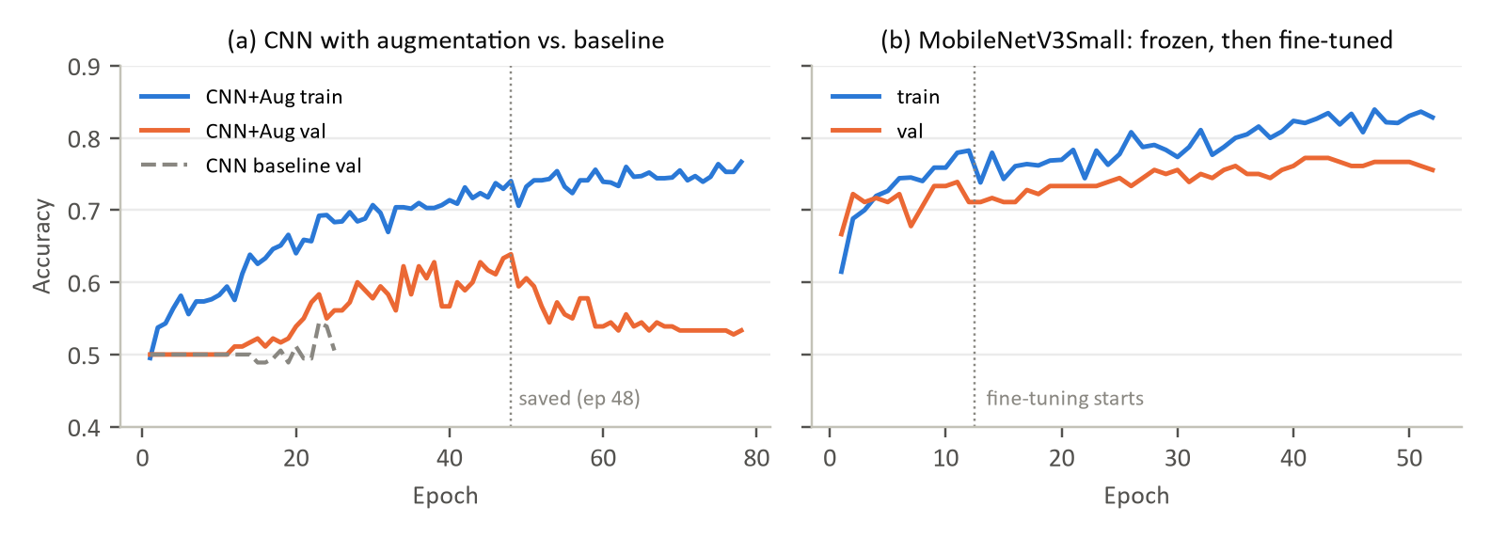
Figure 1. Training and validation accuracy. (a) The augmented CNN compared with the baseline's validation accuracy. (b) MobileNetV3Small with a frozen backbone for 12 epochs, then fine-tuned starting from the best frozen checkpoint (epoch 5).
In my run the baseline CNN never really started learning. Its validation accuracy stays near 0.50 for all 25 epochs, the saved checkpoint is from epoch 1, and its test accuracy is at chance. The output saved in the provided notebook shows the same cell reaching 0.657, so this architecture is quite sensitive to initialisation and to how long it trains. With augmentation and the longer schedule, the same network reaches 0.64 validation accuracy around epoch 48. After that, validation accuracy falls back towards 0.53 while training accuracy keeps rising, so it is starting to overfit and the checkpoint choice matters. MobileNet converges within a few epochs, and fine-tuning adds a slow, steady gain while the training and validation curves stay close together.

4. Analysis
Performance ranking. The fine-tuned MobileNet is best at 0.770 test accuracy, followed by the frozen MobileNet (0.723), then the MLP and the augmented CNN (both 0.650), and finally the baseline CNN (0.493). Augmentation with the longer schedule added 15.7 points over the baseline CNN in this run.
Generalization. At the saved epoch, the frozen MobileNet has the smallest train–validation gap (1.5 points), followed by the fine-tuned one (7.3 points) and the augmented CNN (10.1). The MLP has the largest gap: by epoch 20 it is at 84% training accuracy but only 67% on validation, as expected from 6.3 M parameters on 1,020 images. The baseline CNN's gap is close to zero only because it learned almost nothing.
Confusion patterns. The weaker models are lopsided. The augmented CNN calls 75% of test images real (recall 0.90 for real faces but only 0.40 for AI faces). The baseline CNN and the MLP lean the other way and over-predict AI. Both MobileNet models are balanced, and the fine-tuned one has the best precision and recall for both classes.
Failure cases. Five test images fool all five models: two real and three AI. The two real ones are clean, front-facing close-ups of children, which look a lot like typical generated portraits. Of the three AI images labelled real, two are older men with detailed, wrinkled skin, and one is a heavily stylised portrait. That suggests the models partly rely on how smooth or detailed the skin texture is. With only five images this is a guess rather than a finding.
Model consensus. At least one model disagrees with the others on 258 of the 300 images. On those images the fine-tuned MobileNet is right 75% of the time, the frozen MobileNet 70%, and the rest about 61% or less. A simple majority vote of all five models gets 0.753, slightly below the fine-tuned MobileNet alone, because the weaker models mostly add noise.

5. Key insights
Transfer learning was the clear winner. A frozen ImageNet backbone with a small head already beat every model trained from scratch, and careful fine-tuning (low learning rate, frozen batch norm, late blocks only) pushed test accuracy to 0.77. The small CNNs were unstable on a dataset this size, and the training schedule and checkpoint choice affected them about as much as the architecture did. The best model is used in the demo, a 10-round Human vs. Model game built with Streamlit instead of Gradio. Next steps worth trying are a higher input resolution (MobileNet was pre-trained at 224×224), more training data, and features that look directly at high-frequency artifacts.

